User Experience

Mobile MOBA Wireframe + Annotations + Sitemap + Task Flow + Prototype + Design Description and Reference



Michael Fernando – 2101628972

Peter Wira Hutama – 2101629773

Rifqi Amru Bakti – 2101696973

Bina Nusantara University

2019

Splash Screen

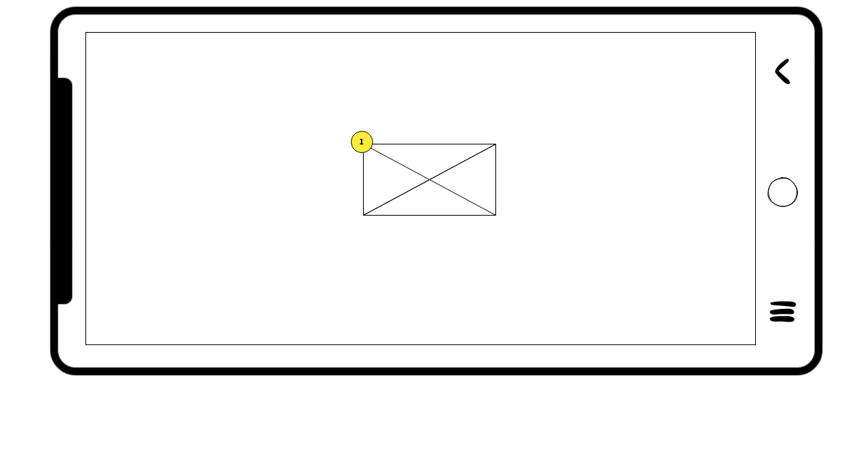

Annotation

1. Shows the image logo to players

Main Menu Screen

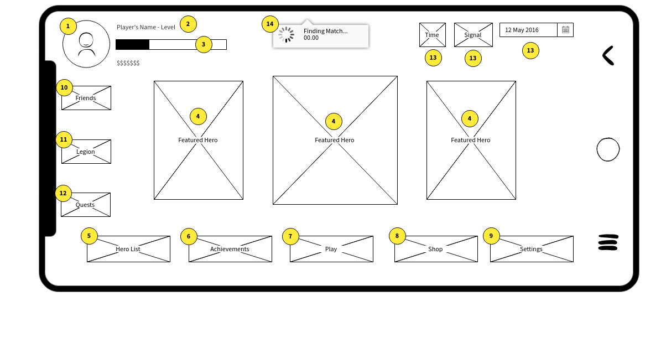

Annotation:

1. Shows the profile photo to player
2. Shows players’s nickname and in-game level
3. Shows player’s progress bar and currency in-game
4. Displays player’s most used heroes
5. Button that player selects to move to Hero Screen
6. Button that player selects to move to Achievements Screen
7. Button that player selects to move to Mode Selection Screen
8. Button that player selects to move to Shop Screen
9. Button that player selects to move to Settings Screen
10. Button that player selects to move to Friends List Screen
11. Button that player selects to move to Legion Information Screen
12. Button that player selects to move to Quests Screen
13. Displays date, time, and the signal strength of player’s internet
14. Displays the time counter used to finding a match

Player Profile (Statistics) Screen

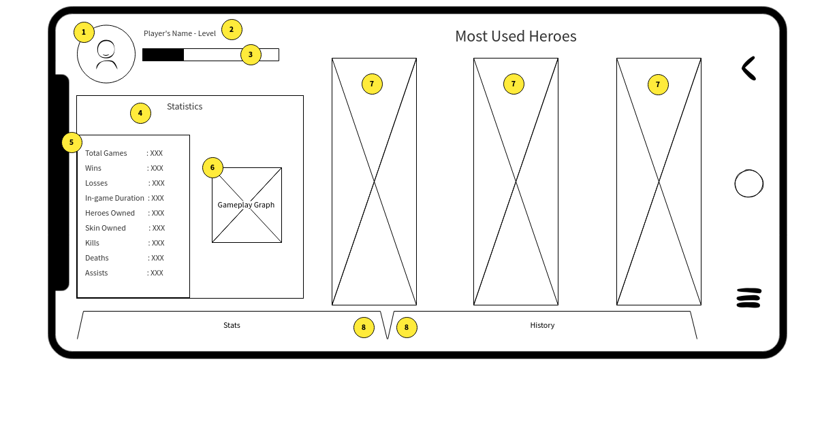

Annotation

1. Shows the profile photo to player
2. Displays the player’s name and level
3. Displays the progress bar until player reach next level
4. Statistics box to show the player statistics
5. Shows the player statistics in number
6. Shows the player statistics in diagram/graph
7. Shows the player what heroes they use the most
8. Button to change from Statistics to History

Player Profile (History) Screen

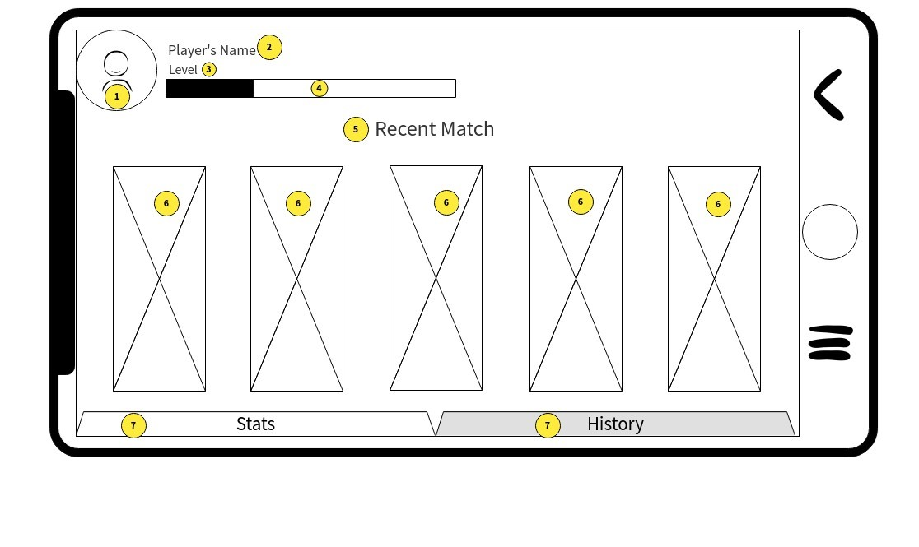

Annotation

1. Shows the profile photo to player
2. Displays the player name
3. Displays the player level
4. Displays the progress bar until player reach next level
5. Text to tell player what the display meaning
6. The previous match(es) and the result(s) with the hero they used
7. Button to change from History to Statistics

Hero List Screen

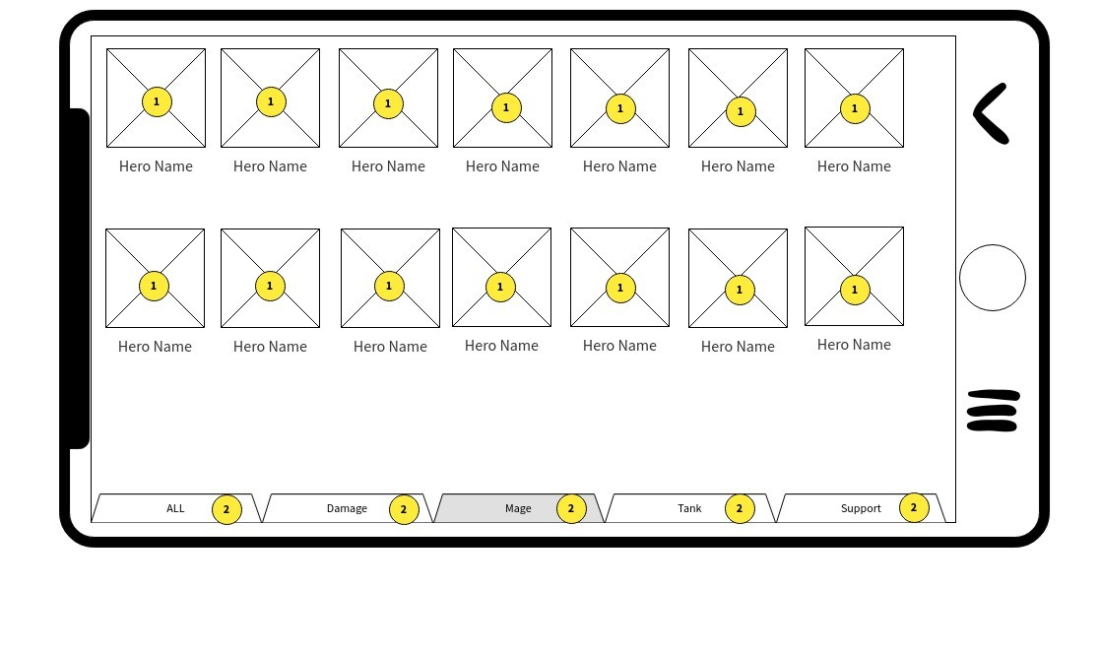

Annotation

1. Displays the Heroes in the current tab
2. Tabs the player select to specify Hero’s type

Hero Description Screen

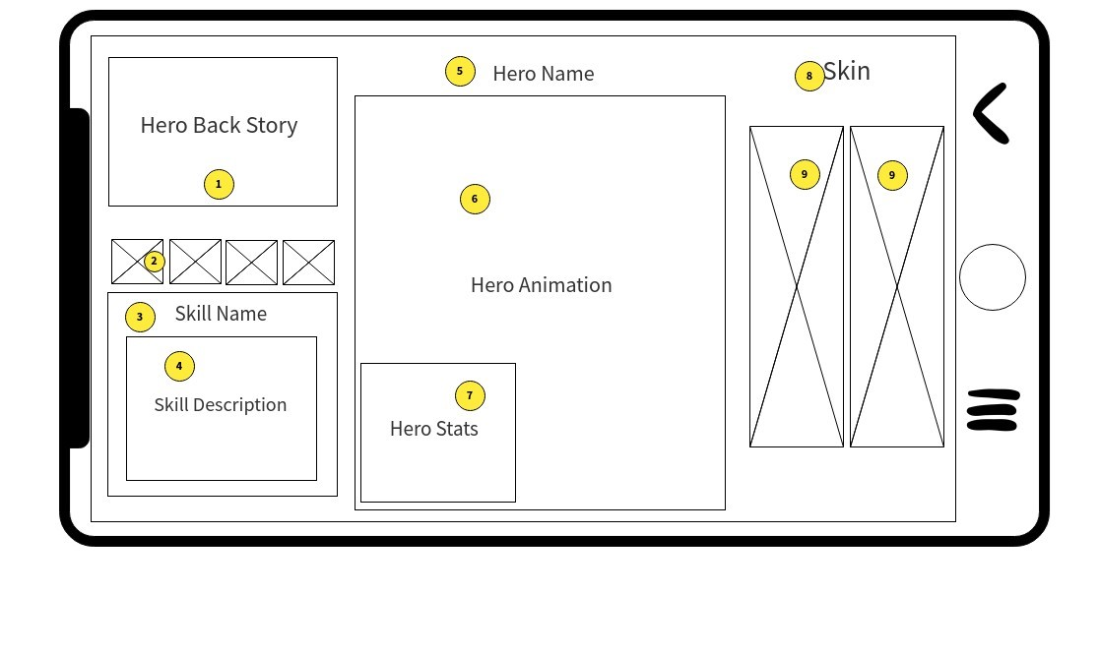

Annotation

1. Displays the player the Hero’s back story
2. Lets the player know the icon for Hero’s skill
3. Tells the player the skill name(s)
4. Give explanation about how the skill work
5. Tells the player Hero’s name
6. Lets the player look at the animation how the hero will show up
7. Gives the player hero statistic so player know what this hero plus and minus stats
8. Tells the player that this is skin area
9. Lets the player look at the skill portrait

Achievements Screen

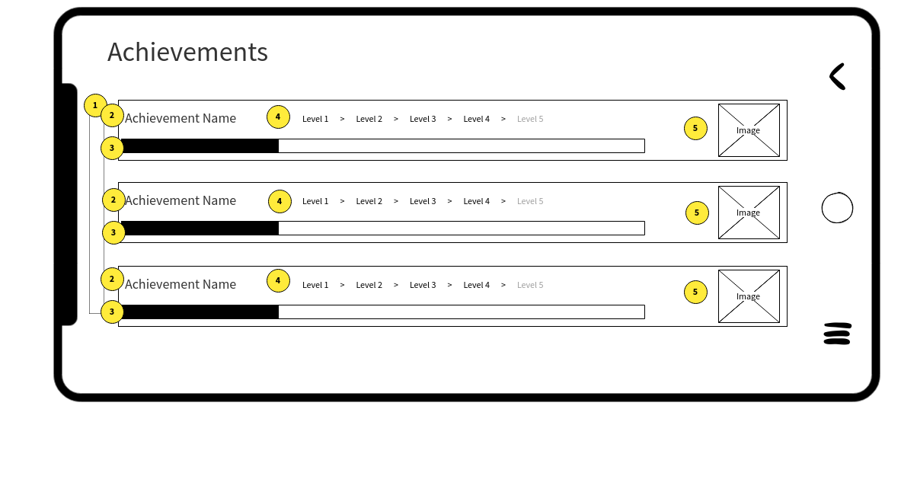

Annotation

1. Scrollbar that is used to scroll up or down the Achievements screen
2. Displays the achievement name
3. Displays the achievement progress bar
4. Displays the current level of achievements
5. Image that player selects will give automated mailbox when achievement reached completion status

Mode Selection Screen

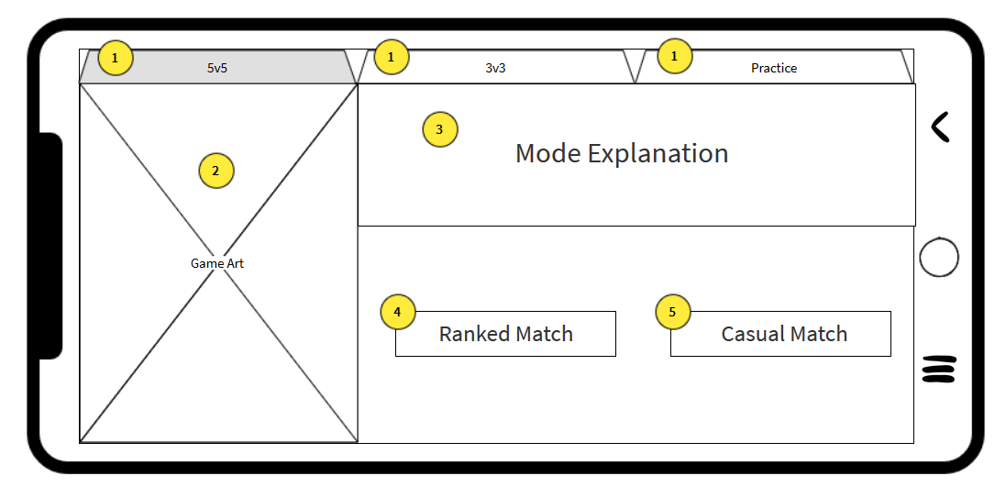

Annotation

1. Tabs the player select to change the game mode to play in
2. Game art that visualize the game mode the player had chosen
3. Explanation on how the game plays out in that mode
4. Button select that the player chose if he wishes to start a ranked game
5. Button select that the player chose if he wishes to start a casual game

Character Selection Screen

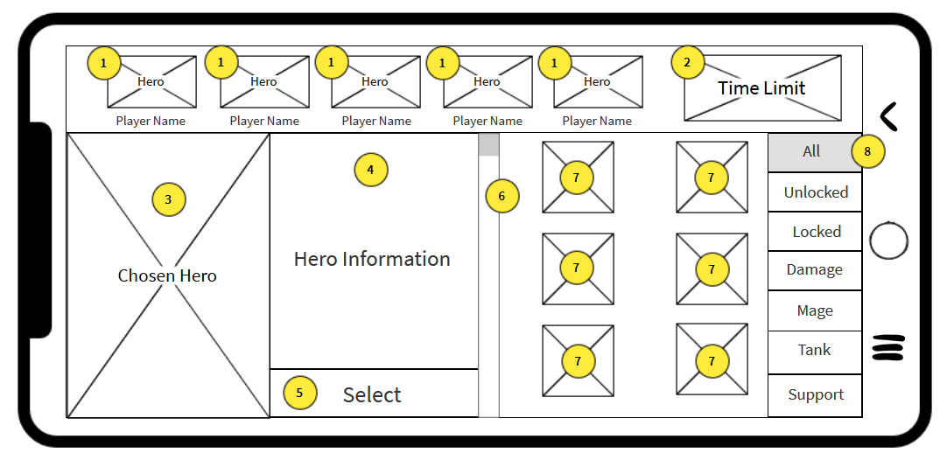

Annotation

1. Displays the hero players have chosen and displays the name of the players
2. Displays the time limit players has to choose character
3. Displays the model/image of the character the player is currently choosing
4. Displays information of the currently selected hero
5. Button select to confirm the hero that the player chose
6. Scrollbar that is used to scroll up or down the character selection screen
7. Displays the variety of heroes the player can choose
8. Tabs the player can choose to sort the heroes based on the tab information

In-Game Screen

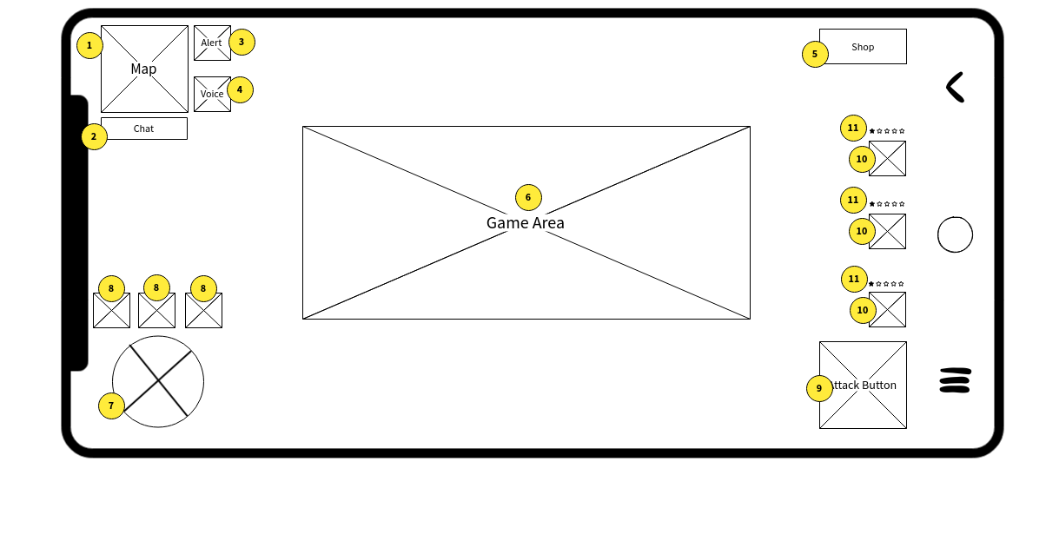

Annotation

1. Displays the game map
2. Button that player selects enable them to communicate with other players
3. Button that player selects allows them to alert the designated map area
4. Button that player selects enables player to communicate with real voice
5. Button that player selects to go to in-game shop
6. Displays the game area
7. Button that player selects to control movements
8. Buttons that player select will activate set skills that unlocked from account level
9. Button that player selects will trigger attack animation
10. Buttons that player select will trigger Hero’s skills
11. Displays the current level of Hero’s skills

Shop Screen

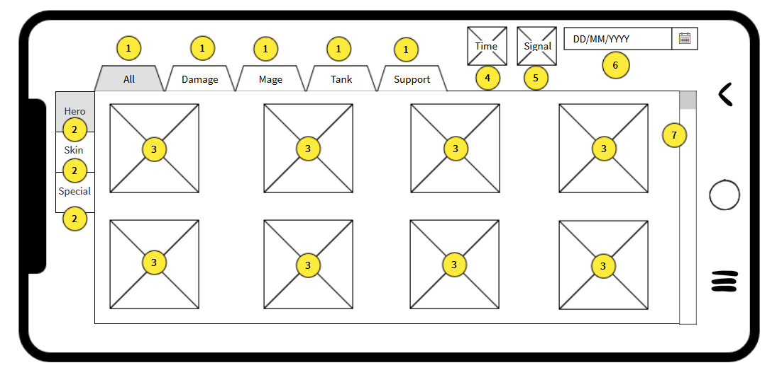

Annotation

1. Tabs player can select to specify the shop’s hero selection
2. Tabs player can select to change the category in the shop
3. Heroes/Things that the player can choose to buy
4. Displays the current time
5. Displays the phone’s signal
6. Displays the current date
7. Scrollbar that can be used to scroll down or up in the shop

Settings Screen

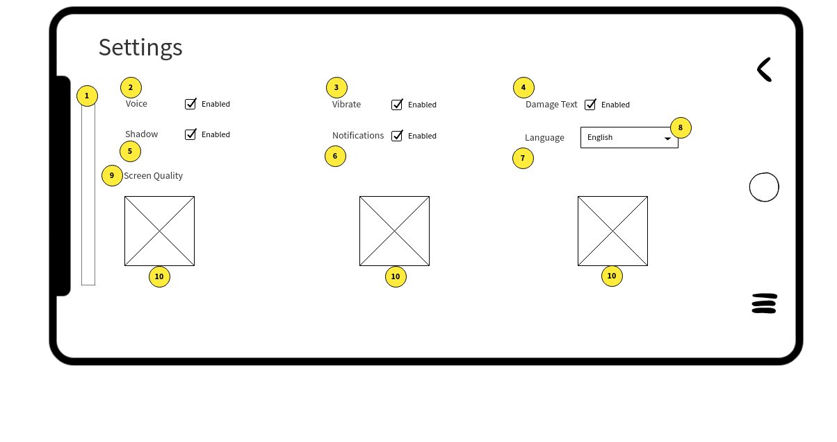Annotation

1. Scrollbar that can be used to scroll down or up in the Settings screen
2. CheckBox that player selects to set Voice on or off
3. CheckBox that player selects to set Vibrate on or off
4. CheckBox that player selects to set Damage Text on or off
5. CheckBox that player selects to set Character Shadow on or off
6. CheckBox that player selects to set Notifications on or off
7. Button that player selects to set default game language
8. Displays the button to change language
9. Buttons that player selects screen quality
10. Shows the images of screen quality

Quest Screen

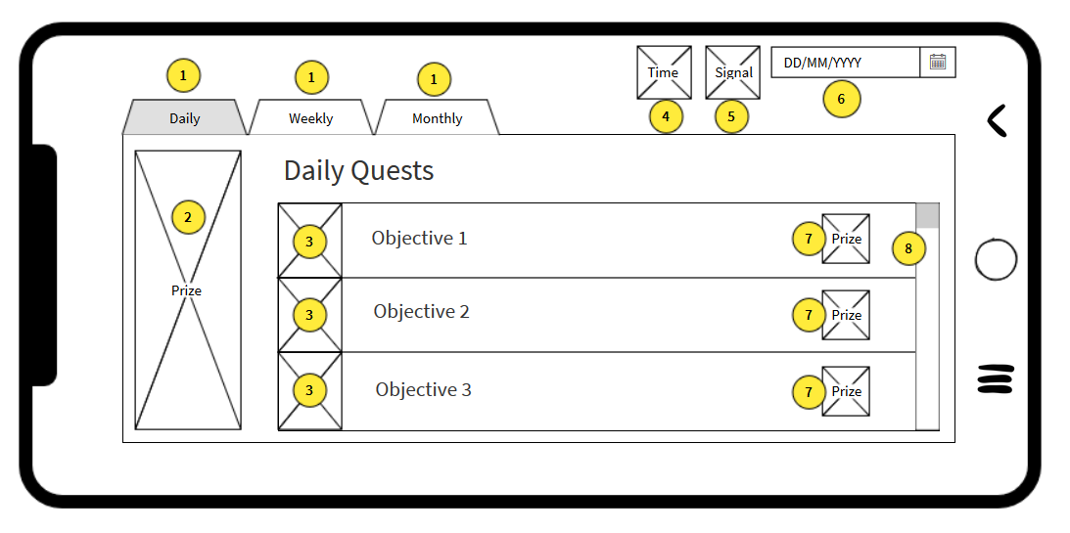

Annotation

1. Tabs the player select to change the type of quest he can see
2. The prize the player will win if he finished all the Quests in that category
3. The objective the player will need to do to complete the quest
4. Displays the current time
5. Displays the phone’s signal
6. Displays the current date
7. The prize player will win if he finished the objective
8. Scrollbar that can be used to scroll down or up in the quest screen

Friend Screen

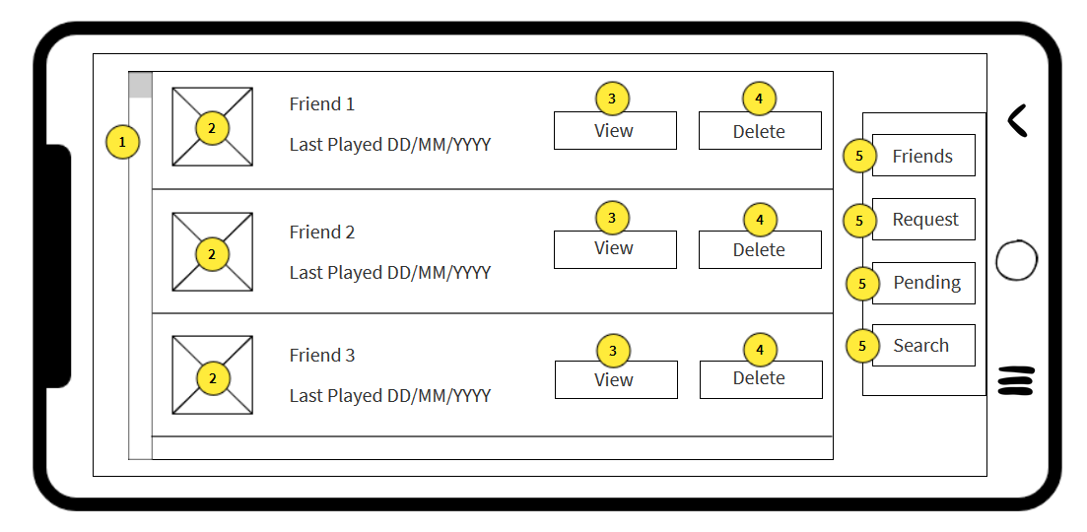

Annotation

1. Scrollbar that can be used to scroll down or up in the friend screen
2. Profiles of the player’s friends
3. Button select to see the stats of the player’s friend
4. Button select to delete the friend
5. Tabs that the player can select to see the Friends, Request, Pending, and Search screen

Legion Screen

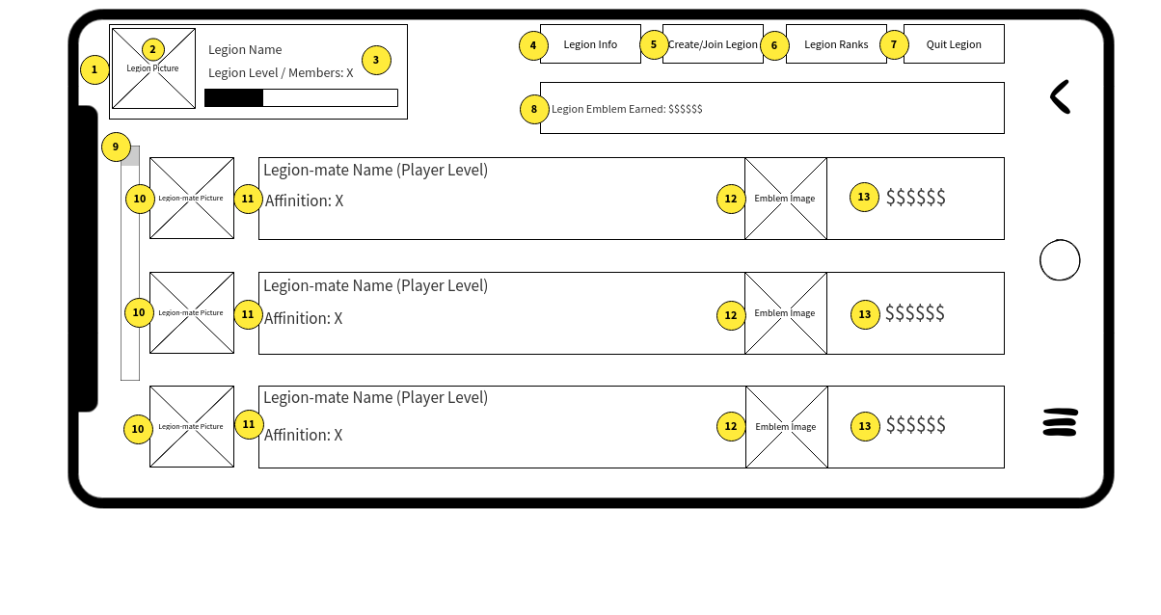Annotation

1. Displays the Legion information
2. Displays the Legion Picture
3. Displays the Legion’s name, level, and members who are in the Legion
4. Tab that player selects to move to Legion Detailed Information Screen
5. Tab that player selects to move to Creating or Joining Legion Screen
6. Tab that player selects to move to Legion Ranks Screen
7. Tab that player selects to confirm the action to quit the Legion
8. Displays the total Legion Emblem gained from Legion members
9. Scrollbar that can be used to scroll down or up in the Legion screen
10. Displays Legion member’s profile pictures
11. Displays Legion member’s name, level, and current affinition in the Legion
12. Displays the default Legion Emblem image
13. Displays the amount of Legion Emblems gained from each Legion members

Legion (Advanced) Screen

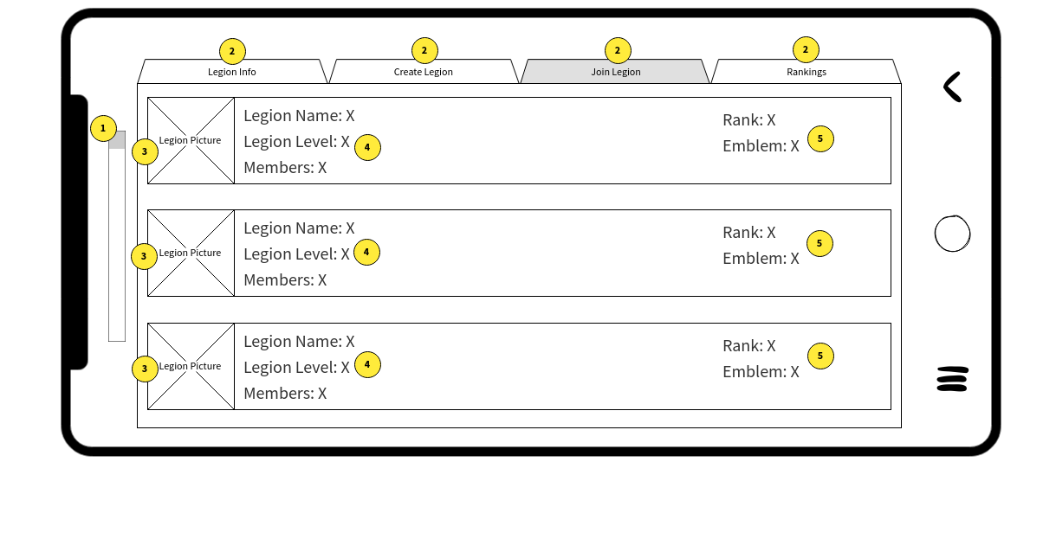Annotation

1. Scrollbar that is used to scroll up or down the Advanced Legion screen
2. Tabs that player select go to current Legion information, creating or joining a Legion, and displays Legion Rankings
3. Displays Legion Picture
4. Displays Legion’s current statistics
5. Displays Legion’s current rank and Emblem gained

Game Result Screen

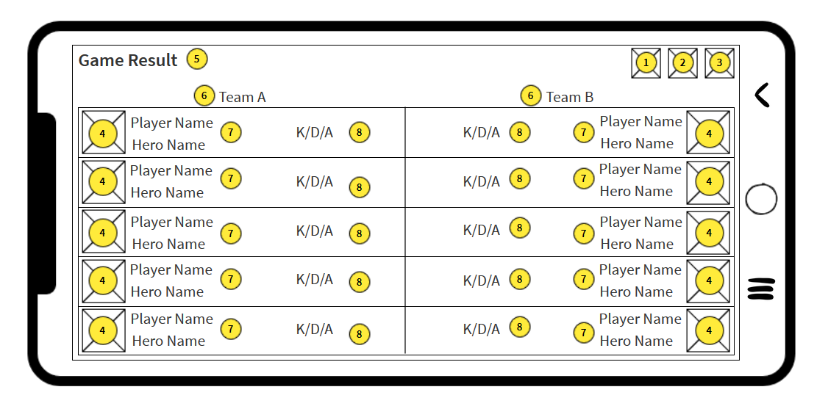Annotation

1. Displays Battery icon
2. Displays Connection Icon
3. Displays Wi-Fi icon
4. Displays player image
5. “Game Result” Text
6. Displays player team and enemy team
7. Displays Player name and Hero name
8. Displays player’s K/D/A count

Legion Rank Screen

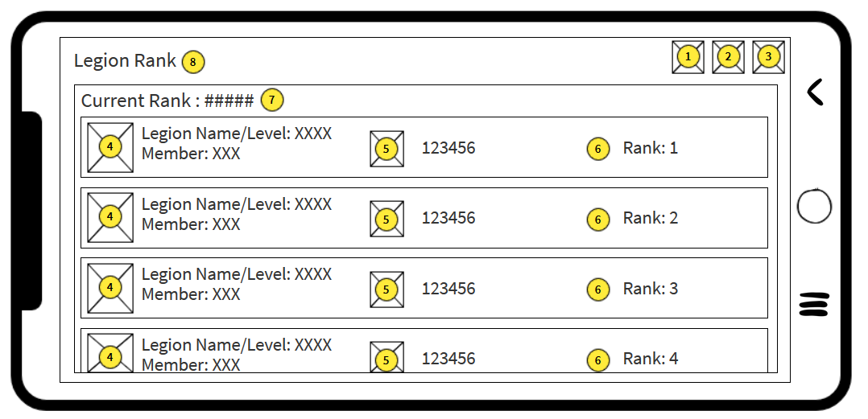Annotation

1. Display Battery icon
2. Display Connection Icon
3. Display Wi-Fi icon
4. Display Legion image
5. Display medal image and point accumulation
6. Display Legion Rank
7. Display current rank of player’s Legion
8. “Legion Rank” text

In-game Shop Screen

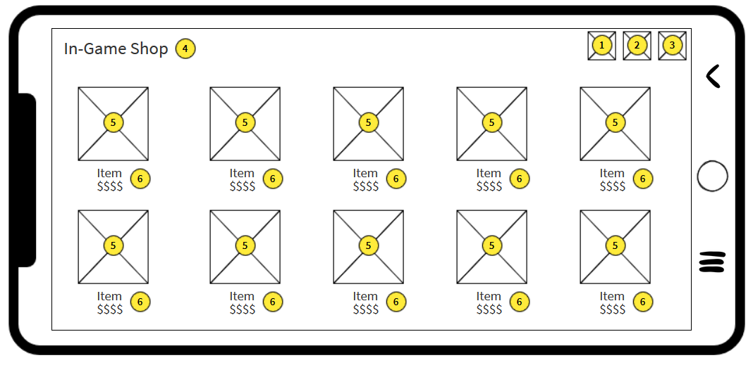Annotation

1. Display Battery icon
2. Display Connection Icon
3. Display Wi-Fi icon
4. “In-Game Shop” text
5. Display Item image
6. Display item name and price

Design Description and Reference

1. We took the ideas from various mobile game design, revolving only on MOBA. As example, we took the layout design from Mobile Legends: Bang Bang. We decided to make the design into our liking because for us the design lacks some aesthetic view.
2. As for character design we took the artwork of some famous anime character, mobile games, and console games. As example, All Might from My Hero Academia, Patapon characters design from Patapon franchise (PlayStation Portable), and Saber from Mobile Legends: Bang Bang.
3. We also took some references from Arena of Valor for mobile games.
4. As for the references from other MOBA games, we took examples from Dota and League of Legends.